**Messaging App**

**Adina Zafar**

**SP24-BSE-006**

1. **Message.java**
2. **MessagingApp.java**
3. **MessageDriver.java**

**Attributes of the Main Classes:**

**Message Class:**

1. **static int idCounter:** For generating unique message IDs.
2. **String sender:** The name of the person sending the message.
3. **String receiver:** The name of the person receiving the message**.**
4. **String content:** The actual content or text of the message.
5. **String messageId**: A unique identifier for each message, generated using the idCounter.
6. **boolean status**: A flag indicating whether the message has been seen (true) or is still unread (false).
7. **LocalDateTime timestamp:** The date and time when the message was created, represented as a LocalDateTime object.

**MessagingApp Class:**

1. **String[] contacts**: An array to store the names of contacts in the messaging app.
2. **Message[][] messages**: A 2D array to store messages for each contact.
3. **int contactCount**: An integer to keep track of the number of contacts added to the app.
4. **String sender**: A constant string representing the sender's name, which is set to "MainSender".
5. **static final int MAX_CONTACTS**: : A constant defining the maximum number of contacts that can be stored in the app.
6. **static final int MAX_MESSAGES_PER_CONTACT**: A constant defining the maximum number of messages that can be stored for each contact.

**MessageDriver Class:**

1. **MessagingApp messagingApp:** An Instance of the MessagingApp class for managing messaging functionalities.
2. **Scanner scanner:** A Scanner object for reading user input.

**UML Diagram:**

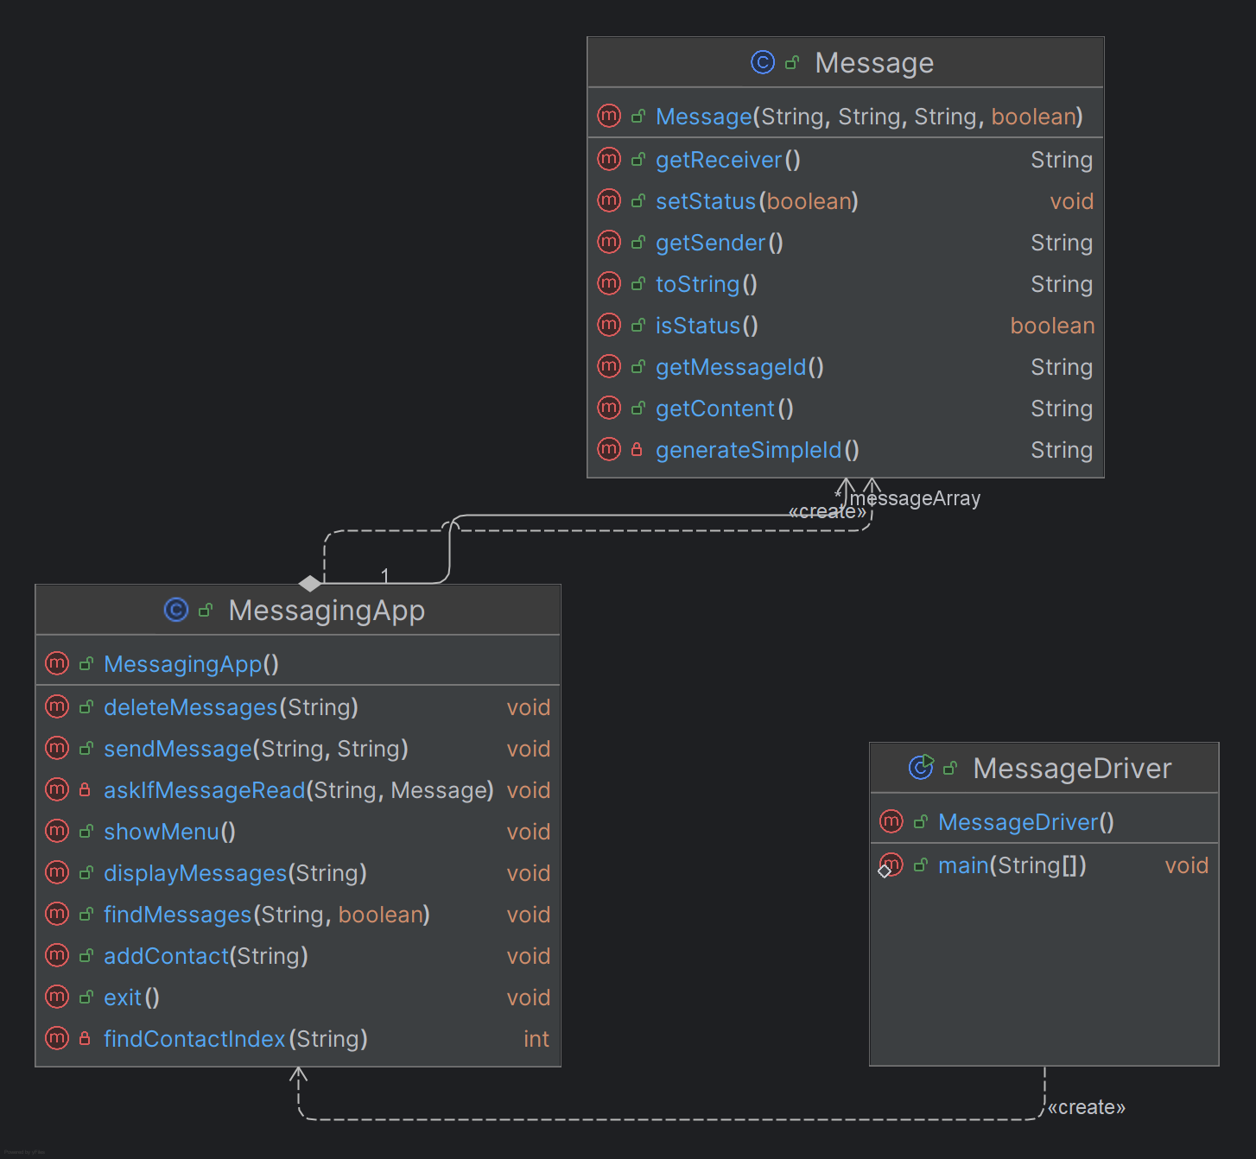**Menu Screen:**

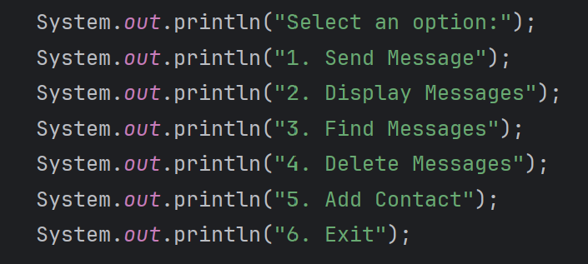

**Source code:**

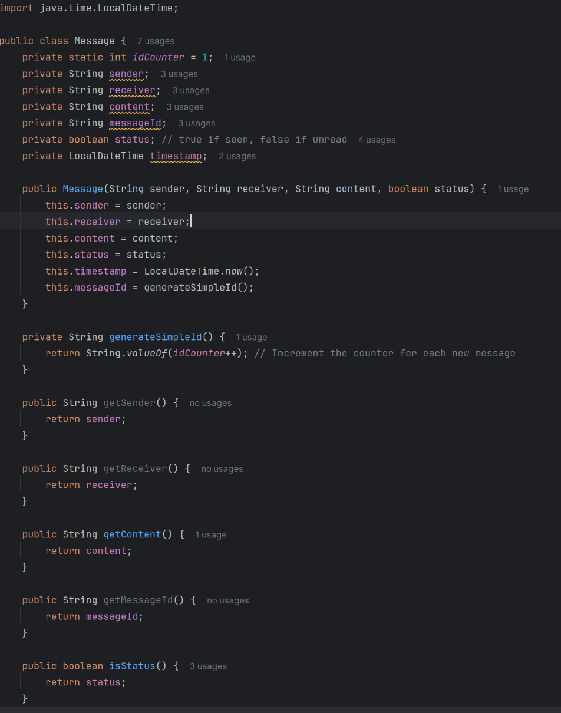**Message class:**

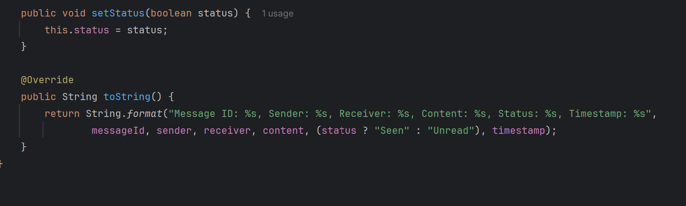

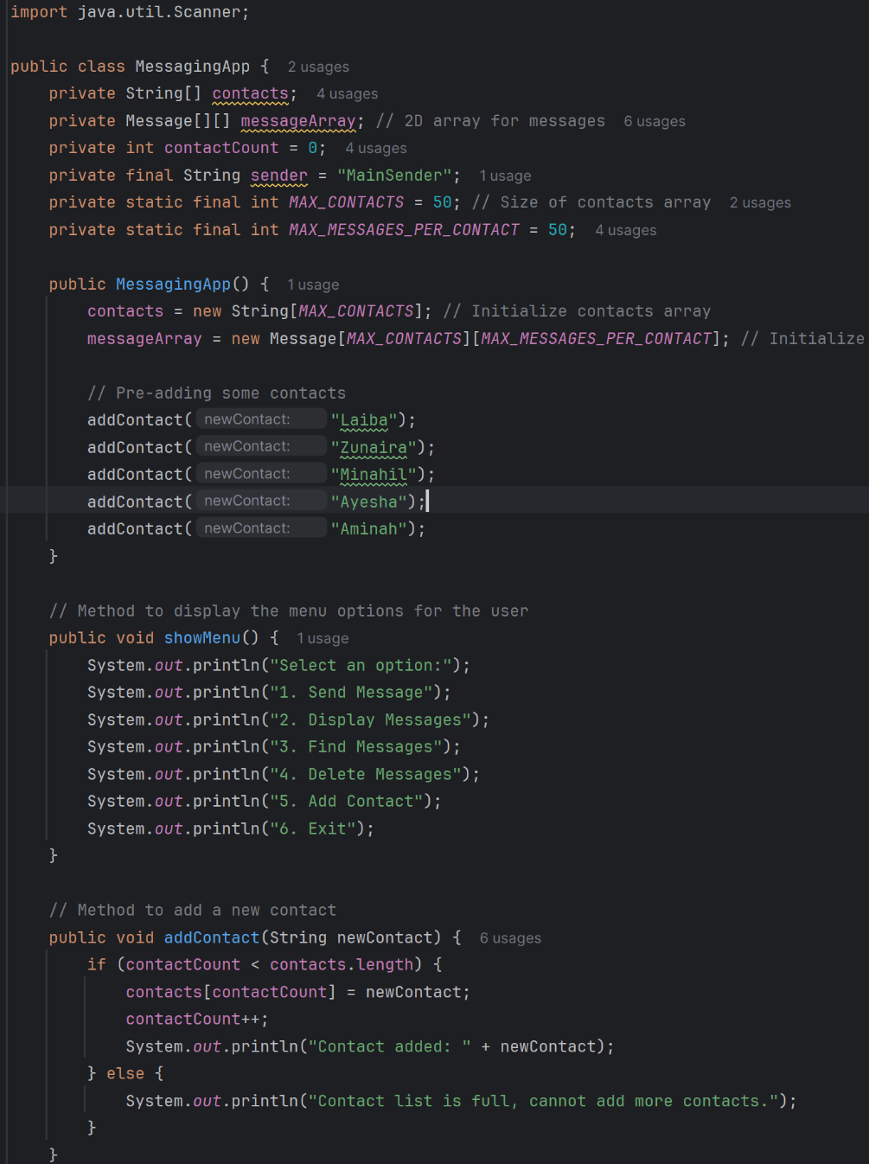**MessagingApp Class:**

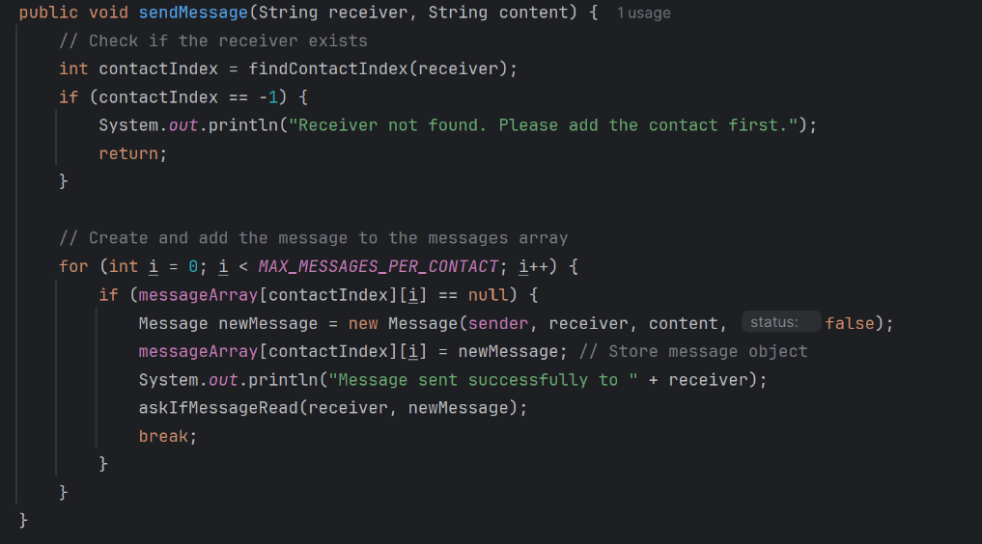

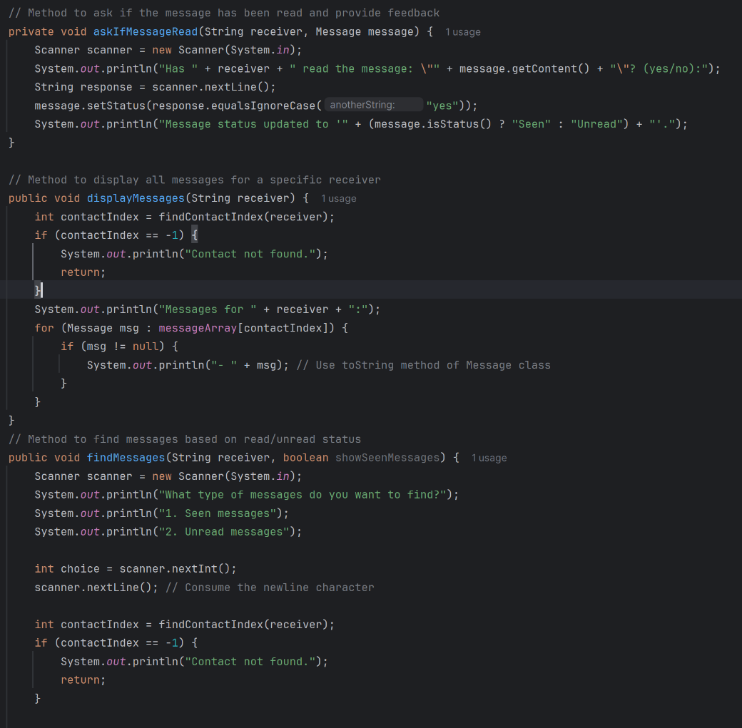

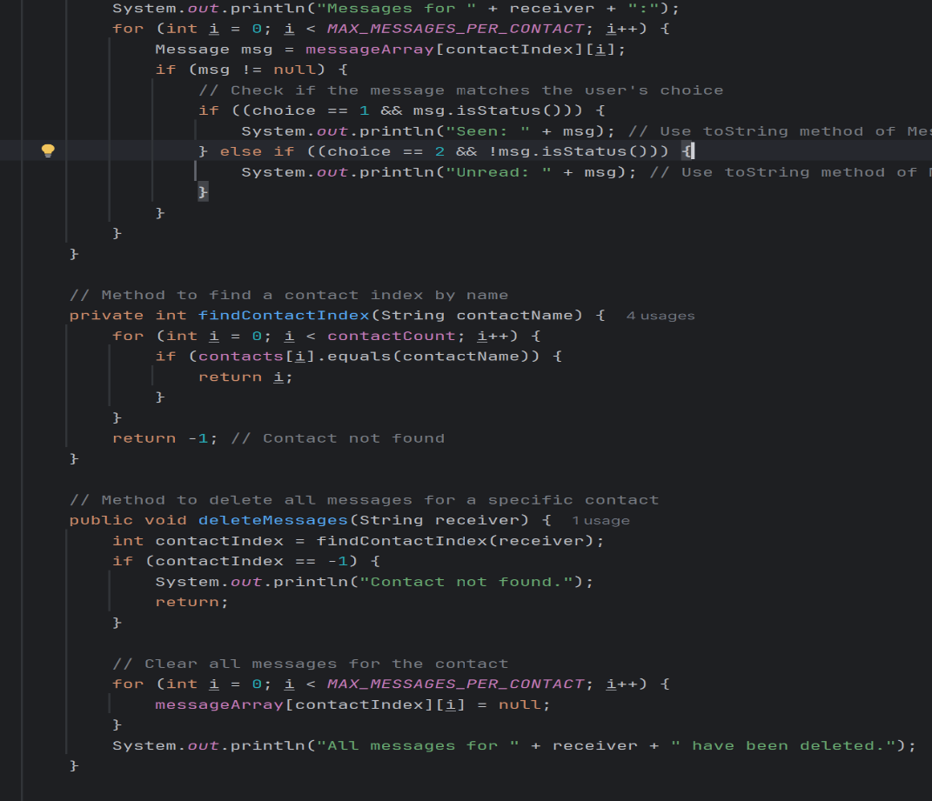

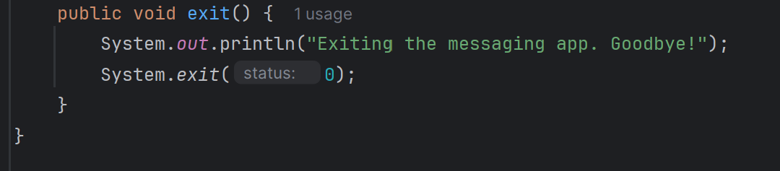

**MessageDriver Class:**

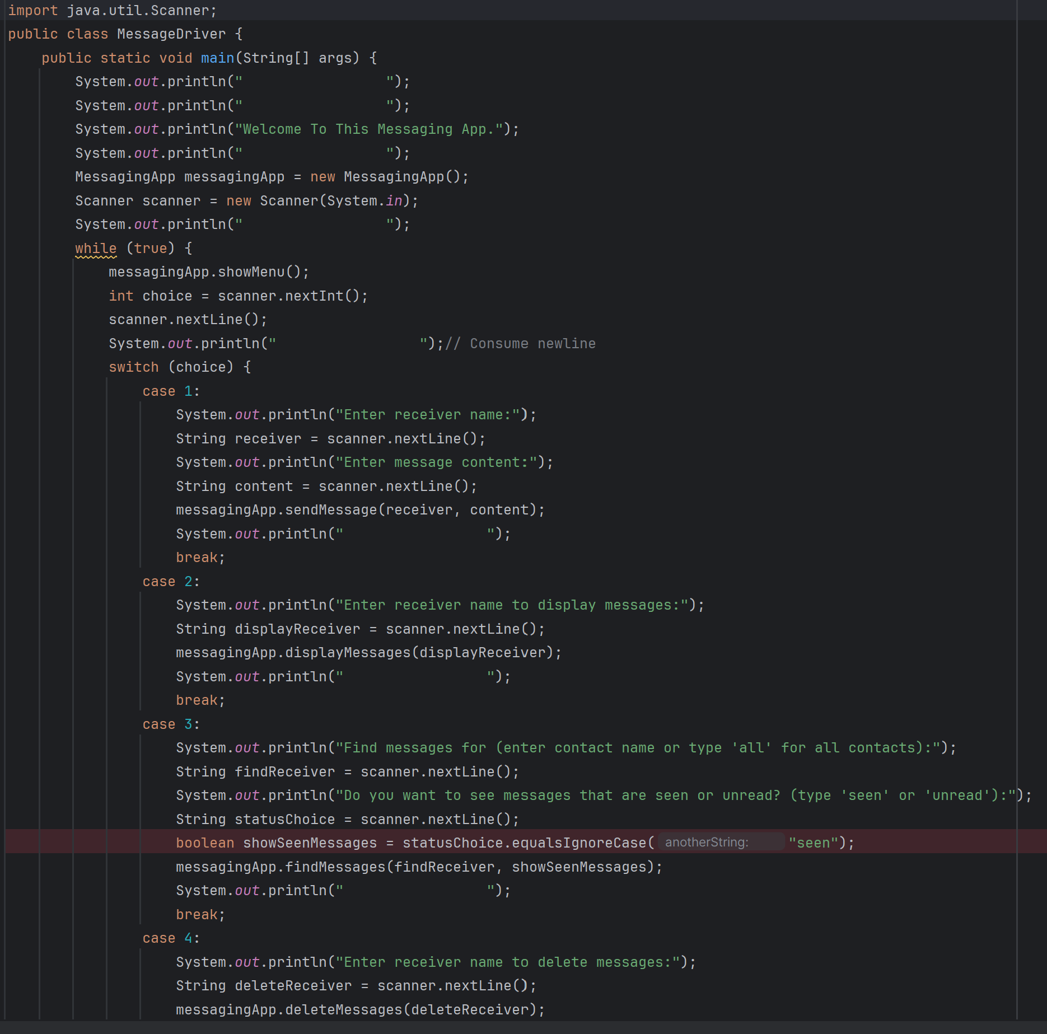

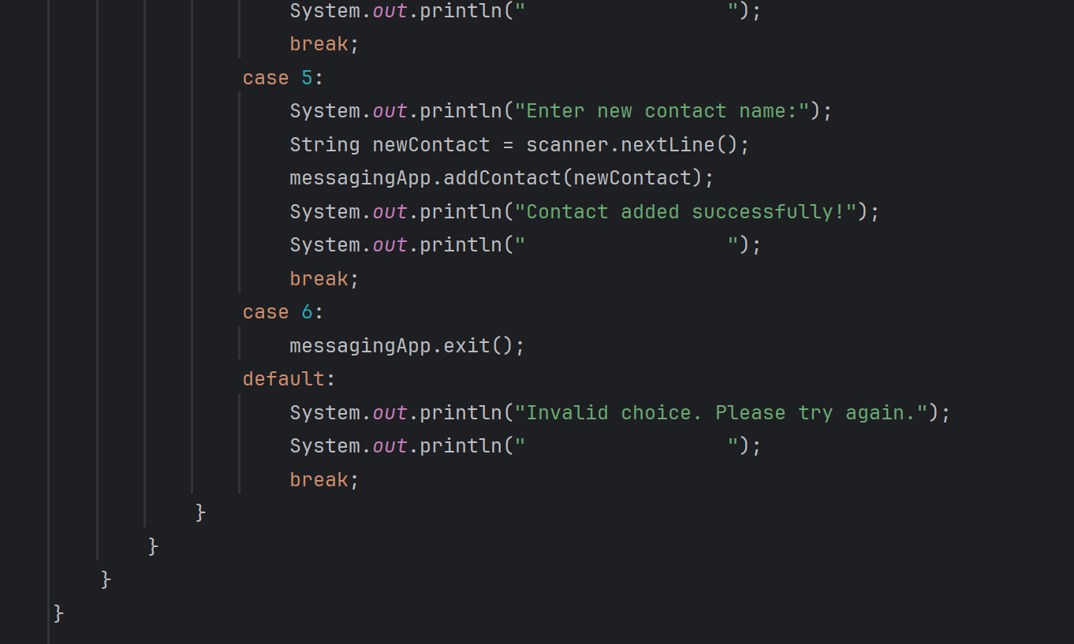

**Iterative model:**

* In first iteration , I built method of sending and displaying message after declaring the variables and initializing arrays. After that, I tested my code to solve errors and improve my methods functionality.
* In second iteration, I added methods like searching and deleting messages and solved further errors.
* In third iteration, I enhanced the display to make it more user friendly and go through the entire code and it’s output many times to make sure that there are no remaining issues.

Sample Output:

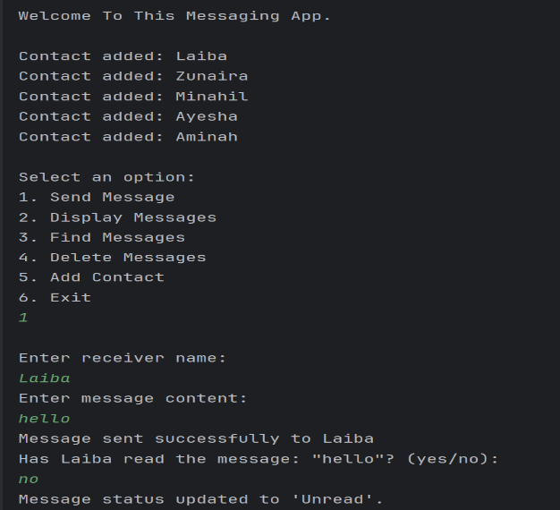send message:

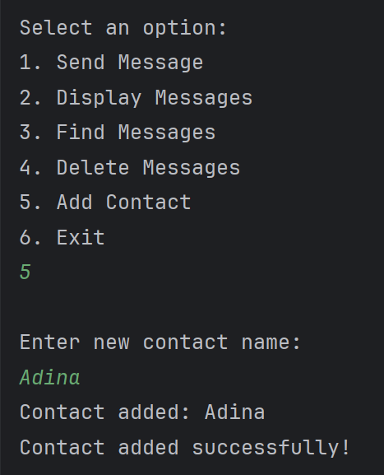Add Contact:

Display Message:

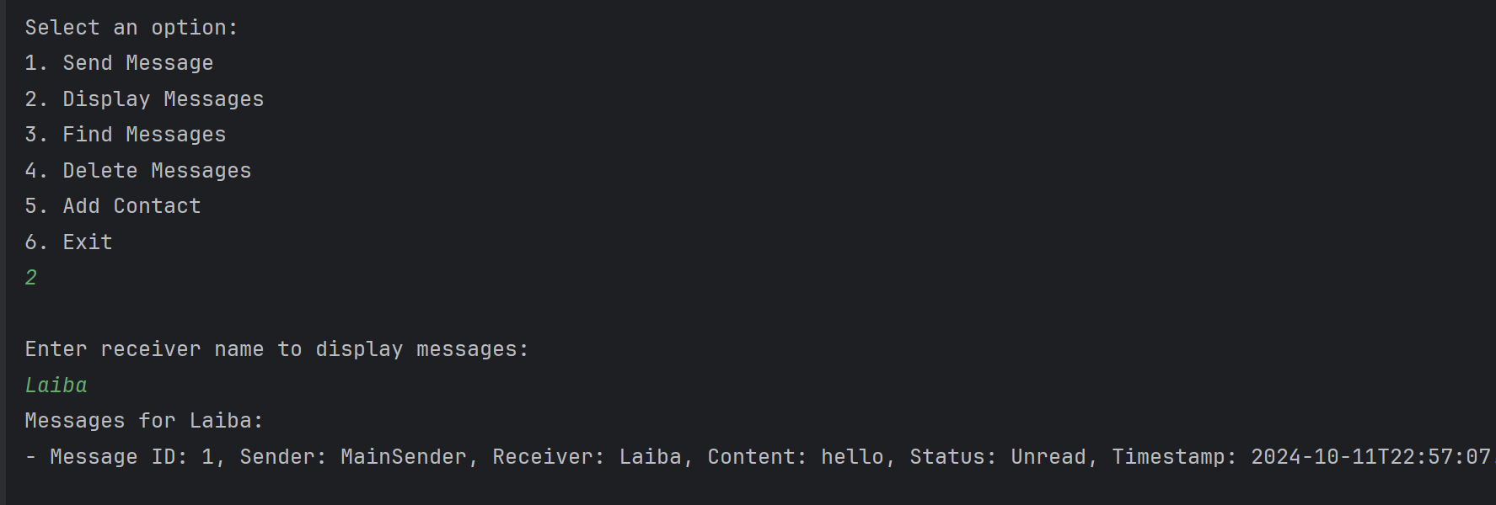

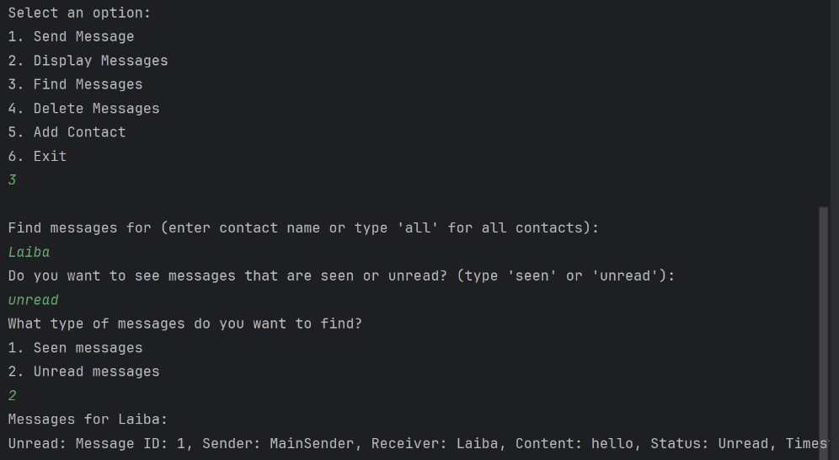Find Message:

Delete Message:

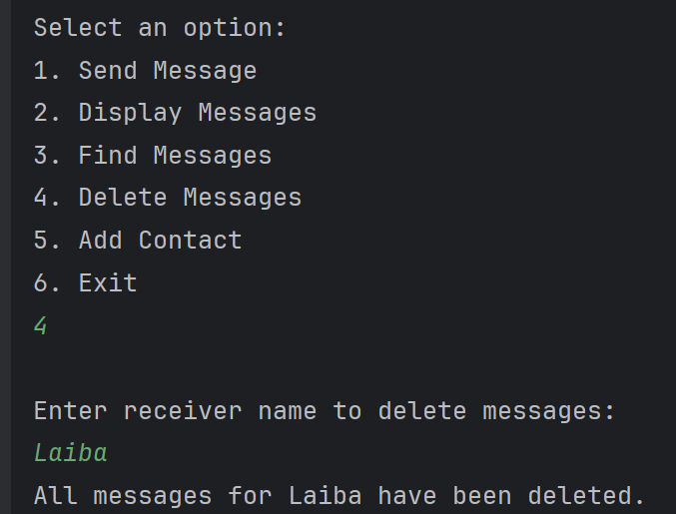

Exit Code:

